Day 2

1. Write a C program to count number of times A E I O U present in the given string.

#include <stdio.h>

#include <string.h>

int main()

{

char str[100];

int vowels = 0;

printf("Enter a string: ");

fgets(str, 100, stdin);

for(int i = 0; i < strlen(str); i++)

{

if(str[i] == 'a' || str[i] == 'e' || str[i] == 'i' || str[i] == 'o' || str[i] == 'u' || str[i] == 'A' || str[i] == 'E' || str[i] == 'I' || str[i] == 'O' || str[i] == 'U')

{

vowels++;

}

}

printf("Number of vowels: %d", vowels);

return 0;

}

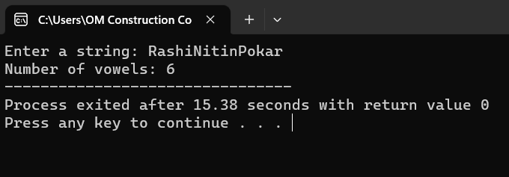

1. Write a C program to calculate sum of elements in an array.

#include<stdio.h>

#include<string.h>

int main()

{

int a[100],i,n,sum=0;

printf("Enter size of the array : ");

scanf("%d",&n);

printf("Enter elements in array : ");

for(i=0; i<n; i++)

{

scanf("%d",&a[i]);

}

for(i=0; i<n; i++)

{

sum+=a[i];

}

printf("sum of array is : %d",sum);

return 0;

}

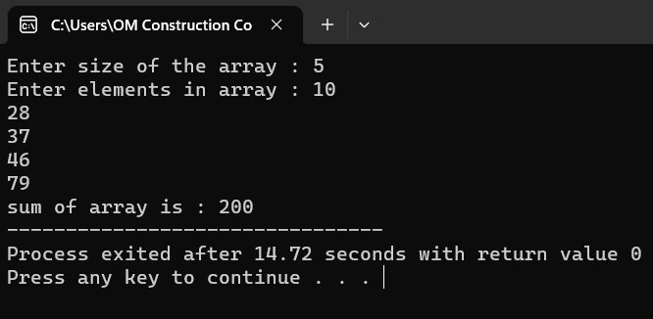

1. Write a C program to merge 2 arrays.

#include<stdio.h>

#include<conio.h>

int main()

{

int arr1[50], arr2[50], size1, size2, i, k, merge[100];

printf("Enter Array 1 Size: ");

scanf("%d", &size1);

printf("Enter Array 1 Elements: ");

for(i=0; i<size1; i++)

{

scanf("%d", &arr1[i]);

merge[i] = arr1[i];

}

k = i;

printf("\nEnter Array 2 Size: ");

scanf("%d", &size2);

printf("Enter Array 2 Elements: ");

for(i=0; i<size2; i++)

{

scanf("%d", &arr2[i]);

merge[k] = arr2[i];

k++;

}

printf("\nThe new array after merging is:\n");

for(i=0; i<k; i++)

printf("%d ", merge[i]);

getch();

return 0;

}

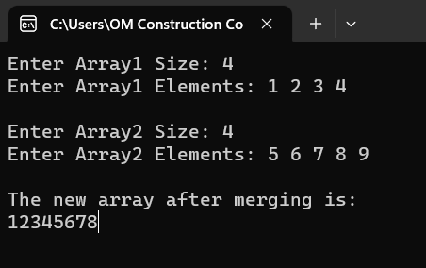

1. Write a C program to reverse a string.

#include<stdio.h>

#include<string.h>

int main ()

{

char str[100];

printf("enter the string to be reversed ");

scanf("%s",&str);

printf("after the reverse of the string %s",strrev(str));

return 0;

}

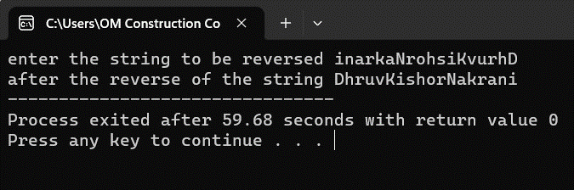

1. Write a C program to insert an element in middle of array.

#include <stdio.h>

#include <conio.h>

int main ()

{

int arr[50];

int pos, i, num;

printf (" \n Enter the number of elements in an array: \n ");

scanf (" %d", &num);

printf (" \n Enter %d elements in array: \n ", num);

for (i = 0; i < num; i++ )

{ printf (" arr[%d] = ", i);

scanf (" %d", &arr[i]);

}

printf( " Delete the element : \n ");

scanf (" %d", &pos);

if (pos >= num+1)

{

printf (" \n Delete is not possible.");

}

else

{

for (i = pos - 1; i < num -1; i++)

{

arr[i] = arr[i+1];

}

printf (" \n The resultant array is: \n");

for (i = 0; i< num - 1; i++)

{

printf (" arr[%d] = ", i);

printf (" %d \n", arr[i]);

}

}

return 0;

}

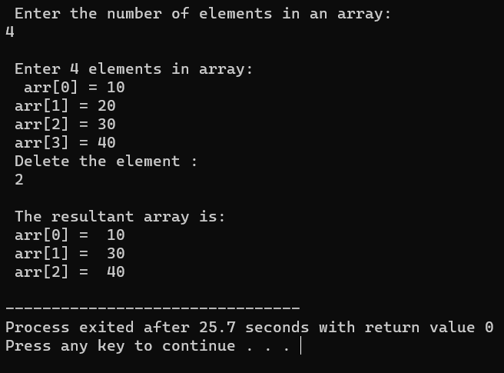

1. Write a C program to check the given string is palindrome or not.

#include <stdio.h>

#include <string.h>

int checkpalindrome(char \*s)

{

int i,c=0,n;

n=strlen(s);

for(i=0;i<n/2;i++)

{

if(s[i]==s[n-i-1])

c++;}

if(c==i)

return 1;

else

return 0;}

int main()

{char s[1000];

printf("Enter the string: ");

gets(s);

if(checkpalindrome(s))

printf("string is palindrome");

else

printf("string is not palindrome");

}

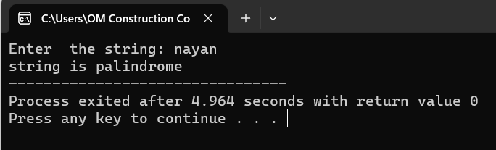

1. Write a C program to search a particular in the string.

#include <stdio.h>

int main()

{

char str[30],ch;

int ind[10],loop,j;

printf("Enter string: ");

scanf("%[^\n]s",str);

printf("Enter character: ");

getchar();

ch=getchar();

j=0;

for(loop=0; str[loop]!='\0'; loop++)

{

if(str[loop]==ch)

ind[j++]=loop;

}

printf("Input string is: %s\n",str);

printf("Indexes: ");

for(loop=0; loop<j; loop++)

printf("%d \t",ind[loop]);

return 0;

}

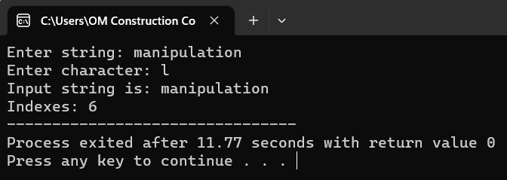

1. Write a C program to perform matrix multiplication

#include<stdio.h>

#include<conio.h>

int main()

{

int mat1[3][3], mat2[3][3], mat3[3][3], sum=0, i, j, k;

printf("Enter first 3\*3 matrix element: ");

for(i=0; i<3; i++)

{

for(j=0; j<3; j++)

scanf("%d", &mat1[i][j]);

}

printf("Enter second 3\*3 matrix element: ");

for(i=0; i<3; i++)

{

for(j=0; j<3; j++)

scanf("%d", &mat2[i][j]);

}

printf("\nMultiplying two matrices...");

for(i=0; i<3; i++)

{

for(j=0; j<3; j++)

{

sum=0;

for(k=0; k<3; k++)

sum = sum + mat1[i][k] \* mat2[k][j];

mat3[i][j] = sum;

}

}

printf("\nMultiplication result of the two given Matrix is: \n");

for(i=0; i<3; i++)

{

for(j=0; j<3; j++)

printf("%d\t", mat3[i][j]);

printf("\n");

}

getch();

return 0;

}

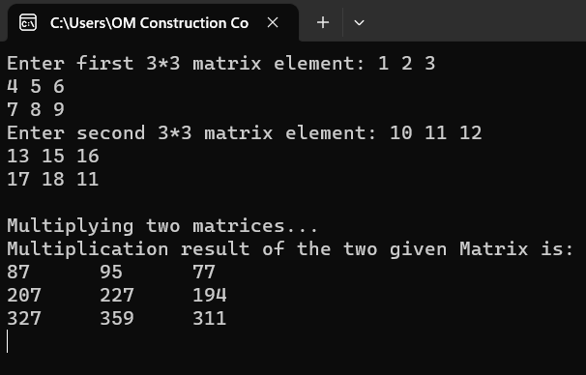

1. Write a C program to perform all string manipulation.

#include<stdio.h>

int main()

{

char name[30];

printf("Enter name: ");

gets(name);

printf("Name: ");

puts(name);

return 0;

}

